<https://www.sciencedirect.com/science/article/pii/S1877705817341231>

For real-time traffic sign recognition, we need to evaluate preprocessing, localization and classification performance. In our case, we used CNN for both localising and classifying the traffic signs.

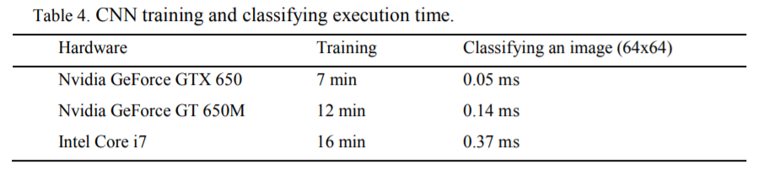

The quality of input images strongly influences the recognition rate.

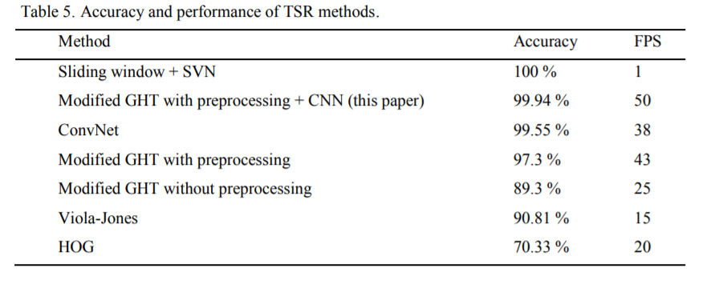

However, traffic sign recognition is not an easy task, because there are many adverse factors, such as bad weather, viewpoint variation, physical damage, etc. As vehicle mounted cameras are not always perpendicular to the traffic signs, and the shape of traffic signs are often distorted in road scenes, the shape information of traffic signs is no longer fully reliable.

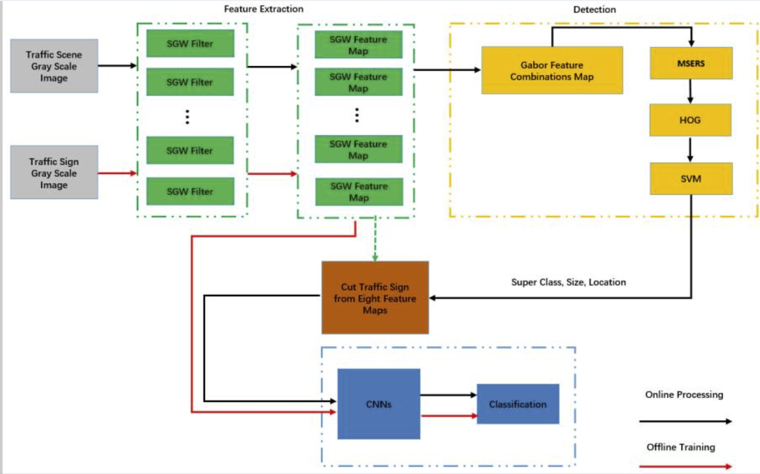

the color images captured by mounted cameras on a vehicle often fail to highlight the shape information, and cannot express the color information stably, which causes the loss of such information. In existing technology, color information enhancement [[22](https://www.ncbi.nlm.nih.gov/pmc/articles/PMC6210476/#B22-sensors-18-03192)] or shape information enhancement [[3](https://www.ncbi.nlm.nih.gov/pmc/articles/PMC6210476/#B3-sensors-18-03192)] methods are usually used as the preprocess stage of traffic sign detection.

